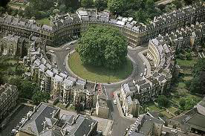 | CARA News
 | Spring 2018
The Circus Area Residents Association (CARA) was formed many years ago to represent the views of local residents and local businesses within our catchment area, as set out on the map on our website.
CARA enables its members to make their voices heard on issues that affect residents.

From the Chairman’s laptop

Welcome to our latest issue of CARA News. Due to the popularity of the earlier colour-printed issues, and with so much going on, we have continued our four pages format. As last time, we are distributing a copy to all homes and businesses within our catchment area, not just CARA members. So, if this copy was put through your front door, you are eligible to join CARA – only £7.50 per household per year, with details at the foot of this Newsletter. Your support enables us to work on your behalf to improve things in our community, alongside our adjacent residents associations. You will see new dates for your diary in this Newsletter – do come and join in, at social events and the ‘business’ meetings. As a Residents Association, we exist only to represent you, and other people living locally. There are various opportunities to meet up, to be sociable or to raise issues that concern you. Do come along – you will be made very welcome.

We need more photo images of CARA events – if you take a good one, please e-mail a copy to Sam Brown, our Committee member with a focus as our website creator and administrator. Sam is also responsible for our Facebook and Twitter accounts – become a Follower to keep up to date with news, views, events and other relevant things happening in and around CARA.

There’s plenty of good news in this Newsletter, including the great result from Carols on the Green; Anne Love winning the Chair of the Council’s “Good Neighbour of the Year” Award and; persistent chivvying by Cindy Beadman has led to the Council installing a very helpful handrail on steps often used by many locals and visitors alike.

On the website, you will find a list of eateries, art galleries and museums within, or adjacent to, the CARA catchment area. One of our three new Committee members, David Simon, compiled this very helpful list. David and his wife Lucy own an art gallery, and so David has adopted a business focus on our Committee. Talking business, we could be open to local businesses sponsoring the production of the Newsletter – does that interest you? We could include a quarter page or half page advert in recognition of your support. You would be surprised how little it costs, perhaps £50 for a half page. Contact one of the Committee by e-mail if you would like to discuss.

With my thanks to everyone involved in the production and distribution of this Newsletter. We all hope that you enjoy reading it and learning more about what the Committee are doing on your behalf. Do you have any new ideas for action or concerns? Just e-mail one of the Committee and we will explore how best we can help.

Barry Gilbertson, Chairman CARA, 2016-2018

Update on our three priorities for 2017/18

- Traffic management. CARA seeks to achieve the optimal traffic volume for local residents. For some years, we have sought to reduce car traffic and eradicate coach traffic. Our efforts have been rewarded with a trial Traffic Management Scheme (TMS) banning coaches from The Circus area and restricting Gay Street to one-way traffic (in a northerly direction). Now that budgetary approval has been received, we are working though the final details with B&NES and will advise more in due course. We expect the new traffic controls to take effect within the next 2-3 months. | 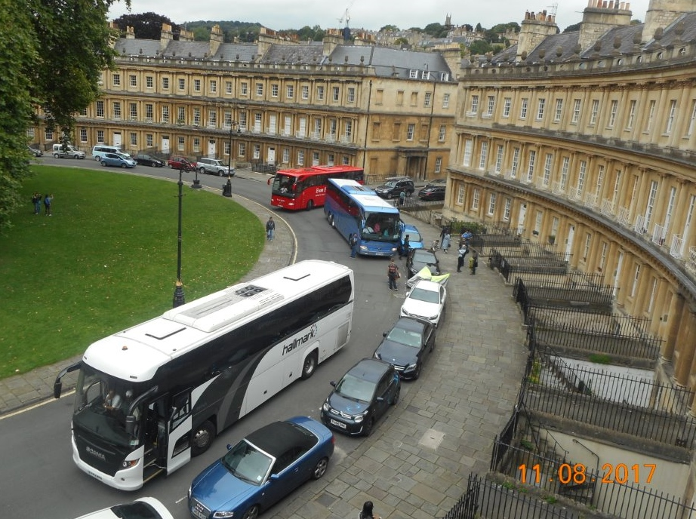
- Air pollution. Many residents will be aware that air pollution is a major problem in our community. Much of the work around improving air quality is out of our hands, but we have (alongside other residents associations in Bath, led by the Federation of Bath Residents’ Association (FoBRA)), raised the profile with local, regional and national government. Recently, B&NES was named in the Government's new Air Quality Plan for Nitrogen Dioxide (NO₂) as one of 29 local authorities with illegal pollution. B&NES is currently seeking feedback on air quality across Bath in preparation for the development of an updated Bath Air Quality Action Plan. B&NES invite you to a drop-in event on Wednesday 21st February at Widcombe Social Club (1.00-5.30pm) where you can find out more about what it is doing to fast-track air quality improvements. The public’s suggestions during the previous consultation helped B&NES produce a list of over 60 ideas to improve air quality. However, more urgent work is required. Last year, the Government issued B&NES with a directive to reduce the high NO₂ levels recorded on London Road ‘in the shortest possible time’ and by 2021 at the latest. To help achieve these targets, B&NES will receive Government funding and expertise. Bath Breathes 2021: The Council set up the Bath Breathes 2021 project to help develop proposals, engage with the public, and meet the Government’s targets and timelines. You can find out more at www.bathnes.gov.uk/breathe.
- Enforcement. Enforcement is a key priority: for example, getting our Council to enforce poor or illegal parking; addressing waste collection and scattered litter problems; and improving street sweeping. Surely everyone now knows that the waste collection routines have changed recently, and that the strong focus is on recycling. This is why our larger black gull-proof sacks were withdrawn at the end of last year, only to be replaced with ones that are half the size. Recycle more and you will produce much less waste. However, it is now clear that anyone putting out waste (rather than recycling) in black plastic sacks or plastic bags or any other container will be warned, a bright yellow sticker on the bag and then the following week a fine of £60 is possible, or even (we are told) likely. The reason for all these changes is simple. Money. Waste costs the Council at least five times as much to send to a waste tip, compared to the income that is received by the Council for selling recycled waste. Recycling boxes are free, and you can order them for delivery (or collect them from the ‘dump’) on the B&NES website. The Council warns that those residents who are fined will find themselves ‘named and shamed’.

Other local issues
- Marlborough Buildings/Cavendish Road proposed junction improvements. The Marlborough Lane and Buildings Residents Association (MLBRA) has been working with B&NES Council on proposed improvement works at the Marlborough Buildings/Cavendish Road junction. The scheme aims to enhance the public realm space around the junction by creating increased footway areas with associated realigning of the carriageway to reduce speed. The main works are scheduled to begin in mid-February (lasting 12 weeks); these will have an impact on traffic flow in the area with Traffic Regulation Order (TROs) governing temporary road restrictions.
- CARA resident wins Award. We are delighted to announce that Anne Love of Rivers Street was recently awarded ‘Good Neighbour of the Year’, alongside Polly Riddle of Park Street, for their independent work in reducing the waste, rubbish and unsightly debris on their streets. It is wonderful to see the recognition of all their hard work. Perhaps you could do something similar around your house or flat? Full story https://carabath.com/special-announcments/
- Cindy Beadman’s achievement. Great news. After much nagging and pushing, about health and safety, the Council have now installed a hand-rail down the steps between Gravel Walk and Royal Avenue. A victory for the community generally, as well as showing the Council in a caring light. Congratulations, Cindy!
- Improve your broadband connection with new voucher scheme. Homes in the B&NES council area could improve their broadband speeds as part of a new Government trial. The Department for Digital, Culture, Media and Sport (DCMS) is, for a limited time, offering vouchers worth £500 towards the cost of getting gigabit-ready broadband installed in local homes as part of the Gigabit Broadband Voucher Scheme. B&NES is one of only two local authorities that will be trialling the scheme. The full fibre connection could radically change speeds for homes, making broadband faster and more reliable.
The scheme is open to groups of residents to apply together, thereby enabling streets or communities to all share the faster speeds. Interested resident groups should contact suppliers directly to see what is possible to install. The £500 scheme voucher will subsidise the costs of setting up the connection. All customers will be expected to commit to a 12 month contract. Further information is available at https://gigabitvoucher.culture.gov.uk.
- Party houses. We have no news on Party Houses, other than to say that CARA, working with FoBRA, and our local Councillors, have been pushing the Council to hold a Scrutiny Day, where the whole issue of party houses is discussed in an open forum (hopefully in late March or early April). We will keep you posted with any update news.
- Trees in The Circus. The remaining 5 London Plane trees in The Circus date to the very early 19th century and were planted thanks to the financial contribution of many Circus owners at that time. The trees are now at record heights and their dominance over The Circus buildings (and, to some, the mere presence of the trees) has created much debate over the years. Indeed, in 1961, Bath Parks Committee considered, but voted against, removing the trees despite the City Planning Officer noting that they were 'out of scale'. An inspection and tree management works did not occur last year as planned but we have been assured by B&NES that the works are imminent.
- Gravel Walk. Residents whose properties back onto Gravel Walk will know that the Council have reinstated the lockable bollard at the Brock Street entrance. The key (and therefore vehicle access) is controlled by Christian Mead from the Highways team. The change is due to unresolved weight restrictions being imposed by a Statutory Undertaking (having the right to do so) over an underground electrical sub-station. The ownership of Gravel Walk is being researched by the Council and our Chairman. If you have any details of your property having any legal rights to motorised vehicular access onto Gravel Walk, please contact barry@barrygilbertson.com.
______________________________________________________________________________________________
Future CARA social events

Just before Christmas, your Committee organized the usual Carols on the Circus event, with some 700 people attending and singing along with the music of the Salvation Army Band. Mulled Wine was sold by the volunteer team from The Circus Restaurant, with all profits still to be added to our collection which raised a superb £1262 so far. Thanks to everyone who came, sang and contributed. Special thanks to Jackie Hampton for all her leadership.

Details on all events are available from Jackie Hampton, Social Secretary on jackie.hampton56@gmail.com
- Ladies social: CARA Ladies meet on the last Thursday of each month at Hall and Woodhouse. Starts at 6pm. No need to book; just turn up. Please feel free to bring your friends (CARA membership not essential).
- Annual General Meeting: Thursday 10th May at 6.30pm for 7.00pm at the Royal Pavilion Café in Victoria Park.
Complimentary drink on arrival. Finger buffet and pay bar after the short business of the meeting. Come and discuss the priorities on which you would like your Committee to focus in 2018/19.
- Georgian Garden Summer Drinks Party: Thursday 21st June at 6.00-9.00 pm at the Georgian Garden at rear of No.4 The Circus, access from Gravel Walk. Cost: £20. Apply to Jackie, please.
- Autumn Social: Friday 21st September at 6.00-8.00pm at David Simon Contemporary Art Gallery, 4 Bartlett Street. A social evening with the opportunity to chat to committee members. Complimentary drinks and snacks. No need to book, but an indication of your likely attendance helps us to cater adequately. Please contact Jackie.
- Christmas lunch. Sunday 9th December at 12.00 noon at Bistrot Pierre. Please contact Jackie.
- Christmas Carols in The Circus: Friday 21st December at 7.00 pm on The Circus green. Come along and join in the Carols with The Salvation Army providing the music. No need to book; just turn up. Charity collection.
- New Year’s Eve: An informal gathering at Hall & Woodhouse from 6.00 pm. Whether you drop in on your way to another venue, or spend the early evening with us, come and join in. Just let Jackie know you are coming.

Other local events
- CARA Litter Pick. On Saturday 10th March, we are planning a litter-pick around the CARA streets of Upper Town, Bath. We have the support of the Council who are providing equipment including day-glo tabards, etc. We meet on Circus Green at 10am for about 90 minutes, or so. This will be a trial event, to see whether it is worth doing once, twice or maybe even three times a year. We have between 6 and 8 volunteers already but the more the merrier. Just bring a pair of gloves! Would you be interested? E-mail barry@barrygilbertson.com See you there!
- CARA Walking Group. Your Committee are considering whether to start a monthly walking group for CARA members. Nothing strenuous and certainly not a hiking group! Just a walk to get some exercise, to meet new people, to chat along the way, perhaps stop for a bite of lunch and amble back. Maybe start at 10.30am from Circus Green, returning after lunch by about 3pm. We need about half a dozen to get us started. Would you be interested? E-mail barry@barrygilbertson.com All ages and abilities welcome.
- Bath Abbey ‘Footprint Project’. Bath Abbey will be holding two free events in March to update the local community on the Footprint Project. Dates: Tuesday 6th March, 2.00-3.00 pm and Monday 19th March, 10.30-11.30am. Meet in the South Transept of Bath Abbey. Charles Curnock, Footprint Project Director, will give a presentation on the latest Footprint plans and their impact on the life of the Abbey. All are very welcome: there is no need to book a place; just arrive a few minutes prior to the start of the presentation to enjoy some light refreshments. If you have any questions, contact Cath Foxwell, Development Officer, on cfoxwell@bathabbey.org
- Museum of East Asian Art exhibition. The Museum of East Asian Art (at 12 Bennett Street) is hosting a British Museum touring exhibition from 4th November 2017 until 22nd April 2018 entitled 'Dressed to impress: netsuke and Japanese men’s fashion'. For further information on this and other exhibitions, see www.meaa.org.uk

CARA Committee 2017/18 Our email addresses are on our website www.carabath.com
Barry Gilbertson | Chairman | Peter Davis | General Matters
Richard Brown | Vice Chairman/Traffic | Jackie Hampton | Social Secretary
Bernard Horn | Secretary | Ron Plant | Member Survey
Mike Richardson | Treasurer | David Simon | Business focus
Sam Brown | Social Media | Ron Temperton | City Centre Action Group

CIRCUS AREA RESIDENTS ASSOCIATION (CARA) Membership form
I wish to join CARA.
Name _______________________________________________________________________
Address _____________________________________________________________________
Telephone _____________________ E-mail Address __________________________________

STANDING ORDER INSTRUCTION FORM
Please complete details to instruct your Bank/Building Society to make a standing order payment. We will do the rest.

To the Manager, Bank/Building Society ___________________________________________________
Postal Address _______________________________________________________________Post Code __________
Name of Account to be debited ____________________________________________
Sort Code _______________________ Account Number ________________________

Please pay to the credit of CIRCUS AREA RESIDENTS ASSOCIATION LIMITED at Lloyds TSB Bank plc, 47 Milsom Street, Bath, BA1 1DN, Sort Code: 30 90 54 Account No: 56601468 on receipt of this order and on 1st April each year the sum of £7.50. I will inform the Bank/Building Society in writing if I wish to cancel this instruction.

Signature_____________________________________________Date__________________________________

Please cut out and return the form to Mike Richardson, CARA Treasurer, 10 Crescent Lane, Bath, BA1 2PU

